* SAS : homework 11：

學號：b07401048 醫學五 姓名：賴柏瑞

* 1. Univariable analysis of age and BMI
     1. Table1：
        1. Continuous variables：

|  |  |  |  |  |
| --- | --- | --- | --- | --- |
|  | **Robust** | **Prefrailty** | **Frailty** | **ANOVA** |
| **Age**  (years) | Mean : 72.0 | Mean : 73.9 | Mean : 76.5 | **p < 0.0001\*** |
| **Education**  (years) | Mean : 13.9 | Mean : 13.4 | Mean : 10.9 | p = 0.0023* |
| **cesdsco score** | Mean : 1.6 | Mean : 3.4 | Mean : 9.9 | **p < 0.0001\*** |

* + - 1. Categorial variables：

|  |  |  |  |  |
| --- | --- | --- | --- | --- |
|  | **Robust** | **Prefrailty** | **Frailty** | **chi-square** |
| **Sex**  Female  Male | 99 (57.56)  73 (42.44) | 115 (51.57)  108 (48.43) | 16 (66.67)  8 (33.33) | p = 0.2427 |
| **APOE e4 status**  Carrier  Non-carrier | 29 (16.86)  143 (83.14) | 35 (15.77)  187 (84.23) | 4 (17.39)  19 (82.61) | p = 0.9483 |

* + - 1. Descriptions：
         1. 三個連續變項age, education year和depression symptom score在frailty的組別的分佈皆呈現顯著的不同。
         2. 其中，age在frailty和robust（4.53, 95% CI = 1.75 – 7.31），以及prefrailty與robust（1.92, 95% CI : 0.63 – 3.22）兩組的組間差異皆達顯著，prefrailty與frailty（2.61, 95%CI = -0.13 – 5.34）兩組未達之差異未達統計顯著。推測ANOVA檢定顯著的結果來自於robust這組與其他兩組顯著不同的貢獻。
         3. Education year在frailty和robust（3.02, 95% CI = 0.95 – 5.09），prefrailty與robust（2.52, 95% CI : 0.48 – 4.57）兩組的組間差異皆達上顯著，prefrailty與frailty（0.49, 95%CI = -0.47 – 1.46）兩組未達之差異未達統計顯著。推測ANOVA檢定顯著的結果來自於robust這組與其他兩組顯著不同的貢獻。
         4. Education year在frailty和robust（3.02, 95% CI = 0.95 – 5.09），prefrailty與robust（2.52, 95% CI : 0.48 – 4.57）兩組的組間difference皆達上顯著，prefrailty與frailty（0.49, 95%CI = -0.47 – 1.46）兩組未達之差異未達統計顯著。推測ANOVA檢定顯著的結果來自於robust這組與其他兩組顯著不同的貢獻。
         5. Depression status在三組之兩兩difference皆達統計上顯著。frailty和robust（8.23, 95% CI = 5.32 – 11.14），prefrailty與robust（1.71, 95% CI : 0.35 – 3.01）和prefrailty與frailty（6.52, 95%CI = 3.65 – 9.39）。
    1. Distribution between cognitive normal and cognitive impairment：
       1. Continuous variables：

|  |  |  |  |  |
| --- | --- | --- | --- | --- |
|  | **cognitive normal** | **cognitive impairment** | **Difference ( 95% CI)** | **t-test** |
| **Age**  (years) | Mean : 72.6 | Mean : 76.2 | **3.62 ( 2.35 – 4.89)** | **p < 0.001* (pooled)** |
| **Education**  (years) | Mean : 14.1 | Mean : 10.6 | **3.54 (2.32 – 4.78)** | **p <0.001* (Satterthwaite)** |
| **cesdsco score** | Mean : 2,6 | Mean : 5.0 | **2.37 (0.52 – 4.22)** | **p = 0.0125* (Satterthwaite** |

* + - 1. Categorial variables：

|  |  |  |  |
| --- | --- | --- | --- |
|  | **cognitive normal** | **cognitive impairment** | **chi-square** |
| **Sex**  Female  Male | 180 (52.25)  158 (46.75) | 51 (62.20)  31 (37.80) | p = 0.1443 |
| **APOE e4 status**  Carrier  Non-carrier | 56 (16.67)  280 (83.33) | 12 (14.63)  70 (85.37) | p = 0.6548 |

* + - 1. Descriptions：
         1. 三個連續變項age, education year和depression score在cognitive normal 和cognitive impairment兩組分佈皆呈現顯著不同。
         2. 其中，education year和depression symptom score兩變項在兩組的變異數顯著不同（兩組folded F p-value < 0.001），故使用Satterthwaite檢定兩組是否有顯著差異；age這個變項在兩組的變異數無顯著差異（folded F p-value = 0.1660），故使用pooled t-test。
    1. Code (q1):

dm "odsresult" clear;

dm "log" clear;

libname data "\\Mac\Home\Desktop\SAS\sas data";

**data** hw11;

set data.frailty_cognition_longdata;

**run**;

*/* homework 11 -- cohort study*/*

*/*q1 : demostrate distribution of variables */*

**data** baseline;

set hw11;

if fu = 0;

**run**;

*/* continuous : age, edu_yr, cesdsco */*

title "univarible grouped by frailty groups";

**proc** **means** data = baseline maxdec = 1;

class frailty_gp3;

var age edu_yr cesdsco;

**run**;

title " age in frailty";

**proc** **anova** data = baseline;

class frailty_gp3;

model age = frailty_gp3;

means frailty_gp3 / bon; */* bonferroni correction */*

**run**;

**quit**;

title "eduyr in frailty";

**proc** **anova** data = baseline;

class frailty_gp3;

model edu_yr = frailty_gp3;

means frailty_gp3 / bon; */* bonferroni correction */*

**run**;

**quit**;

title "cesdsco in frailty";

**proc** **anova** data = baseline;

class frailty_gp3;

model cesdsco = frailty_gp3;

means frailty_gp3 / bon; */* bonferroni correction */*

**run**;

**quit**;

*/* category variables sex, apo4car */*

title "sex and apoe in frailty";

**proc** **freq** data = baseline;

tables frailty_gp3 * sex / nopercent nocol chisq;

tables frailty_gp3 * apo4car / nopercent nocol chisq;

**run**;

*/* q1-2 grouped by mocasco */*

**data** baseline2;

set baseline;

if mocasco = . then mocabi = .;

else if mocasco >= 24 then mocabi = 0;

else mocabi = 1;

**run**;

*/* continuous : age, edu_yr, cesdsco */*

title "univarible grouped by mocabi";

**proc** **means** data = baseline2 maxdec = 1;

class mocabi;

var age edu_yr cesdsco;

**run**;

**proc** **ttest** data = baseline2;

class mocabi;

var age edu_yr cesdsco;

**run**;

*/* category variables sex, apo4car */*

title "sex and apoe in moca";

**proc** **freq** data = baseline2;

tables mocabi * sex / nopercent nocol chisq;

tables mocabi * apo4car / nopercent nocol chisq;

**run**;

* 1. 10% rule to look for confounder （ frailty(E) 🡪 cognitive impairment(DZ) ）
     1. Result ( odds ratio by GLMM model )：
        1. Crude：2.11 ( 95% CI : 1.32 – 3.39)*
        2. Age adjusted：1.51 ( 95% CI：0.93 – 2.47)
        3. Sex adjusted：2.12 ( 95% CI：1.32 – 3.40)*
        4. APOE e4 status adjusted : 2.12 ( 95% CI：1.32 – 3.39)*
        5. Depression symptom score adjusted : 2.14 ( 95% CI：1.28 – 3.55)*
        6. Alcohol drinking adjusted : 2.11 ( 95% CI：1.32 – 3.39)*
        7. Gait adjusted : 1.11 ( 95% CI：0.66 – 1.88)
        8. Hypertension adjusted : 2.08 ( 95% CI：1.29 – 3.34)*
        9. Diabetes adjusted :2.13 ( 95% CI：1.33 – 3.43)*
        10. Hyperlipidemia : 2.06 ( 95% CI：1.28 – 3.30)*
     2. 10% rule :
        1. Age : 28.4% > 10%
        2. Sex : 0.474% < 10%
        3. APOE e4 status : 1.42% < 10%
        4. Depression symptom score：1.42% < 10%
        5. Alcohol : 0.00% < 10%
        6. Gait : 47.4% > 10%
        7. Hypertension : 1.42% < 10%
        8. Diabetes : 0.948% < 10%
        9. Hyperlipidemia : 2.37% < 10%
     3. Descriptions：
        1. 本題我將frailty區分為兩組，robust的為一組，prefrailty和frailty的為一組。
        2. 至於校正的變項中，age, gait 和depression symptom score是連續變項，其餘為類別變項。此外，hypertension, diabetes和hyperlipidemia在原始資料中有三組（沒病史(0), 有病史有吃藥(1)和有病史沒吃藥(2)）。由於有病史沒吃藥這組的樣本數非常少，故將沒病史的分為一組，有病史的分為一組。
        3. 分析結果如上所述，confounder的變項有age和gait。
     4. Final model：
        1. 根據上述分析，最後我將age和gait放入最終模型。得出adjusted odds ratio = 0.986 ( 95% CI : 0.58 – 1.67 ) 。結果由原本顯著變為不顯著，顯示age和gait的confounding effect很大，且bias的方向是away frow null。
        2. 此外，查找文獻得知先前研究認為sex（女性），depression和APOE e4 status都是cognitive impairment的危險因子。嘗試再把這三個變項放入模型，得出adjusted odds ratio = 1.017 ( 95% CI : 0.561 – 1.841 )，未達統計上顯著。
     5. 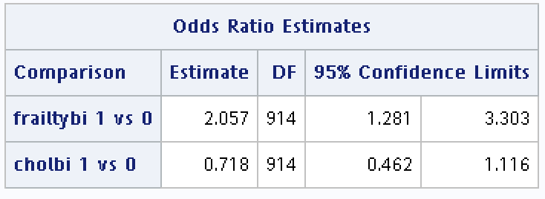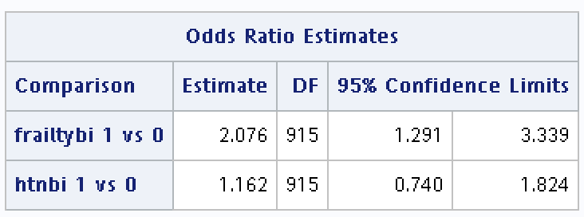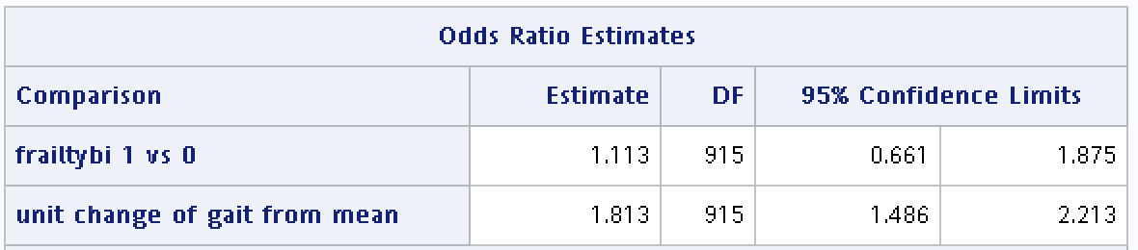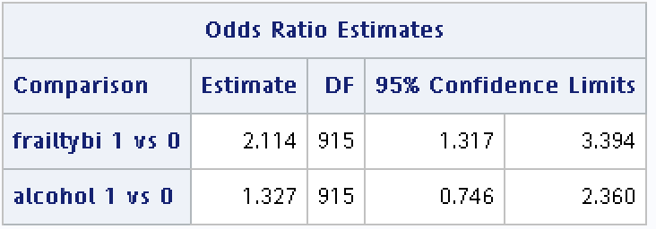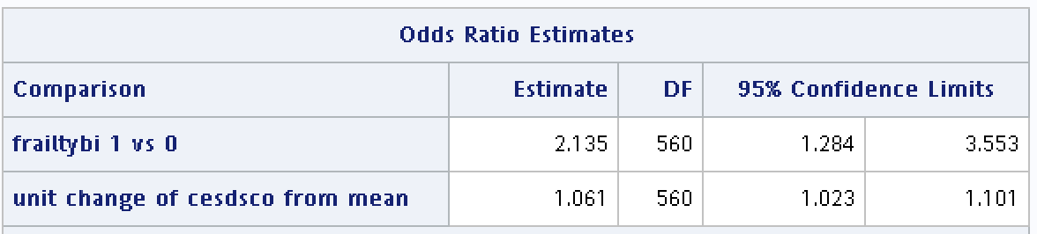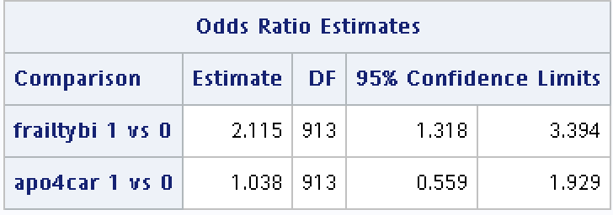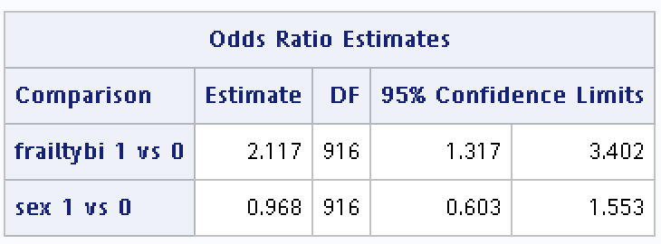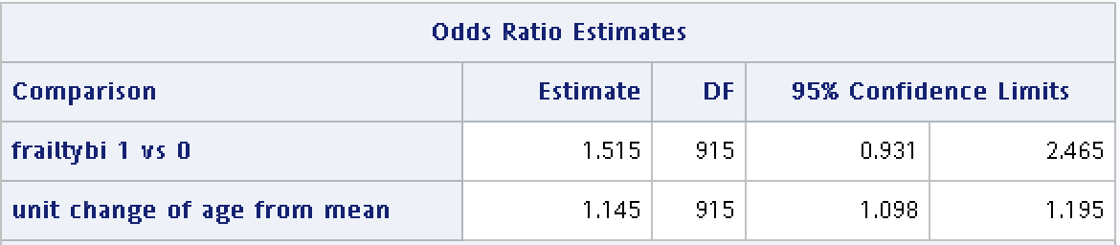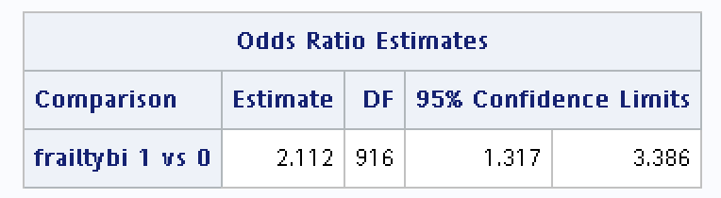Figures：

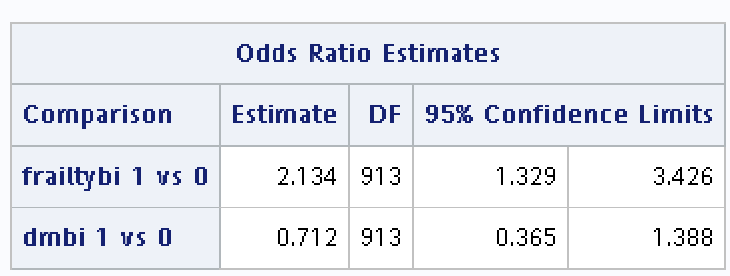

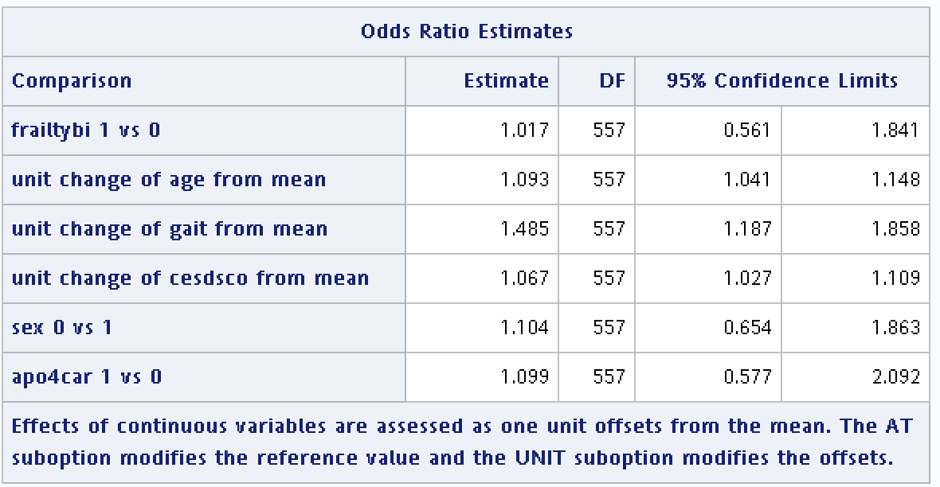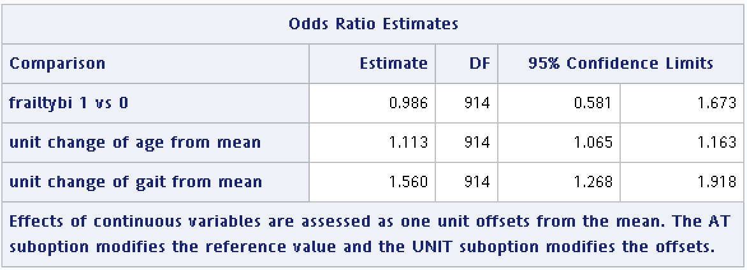

* + 1. Code (q2)

dm "odsresult" clear;

dm "log" clear;

libname data "\\Mac\Home\Desktop\SAS\sas data";

**data** hw11;

set data.frailty_cognition_longdata;

**run**;

*/*q2 : generalized model : frailiry status ( e ) --> moca ( dz ) */*

title "q2 unadjusted";

**data** frailty;

set hw11;

if mocasco = . then mocabi = .;

else if mocasco >= 24 then mocabi = 0;

else mocabi = 1;

if frailty_gp3 = . then frailtybi = .;

else if frailty_gp3 = 0 then frailtybi = 0;

else frailtybi = 1;

if htn = . then htnbi = .;

else if htn = 0 then htnbi = 0;

else htnbi = 1;

if dm = . then dmbi = .;

else if dm = 0 then dmbi = 0;

else dmbi = 1;

if chol = . then cholbi = .;

else if chol = 0 then cholbi = 0;

else cholbi = 1;

**run**;

**proc** **freq** data = frailty;

tables frailty_gp3 * frailtybi;

**run**;

**proc** **glimmix** data = frailty;

class new_id frailtybi(ref = "0");

model mocabi(event = "1") = frailtybi / dist = binary link = logit solution or(label);

random intercept / subject = new_id;

**run**;

*/*q2 : use 10% rule to decide cf to put in model */*

*/* age */*

title "q2 adjust age";

**proc** **glimmix** data = frailty;

class new_id frailtybi (ref = "0");

model mocabi(event = "1") = frailtybi age / dist = binary link = logit solution or(label);

random intercept / subject = new_id;

**run**;

*/* sex */*

title "agjust sex";

**proc** **glimmix** data = frailty;

class new_id frailtybi (ref = "0") sex(ref = "1");

model mocabi(event = "1") = frailtybi sex / dist = binary link = logit solution or(label);

random intercept / subject = new_id;

**run**;

*/*APOE status */*

title "adjust apoe ";

**proc** **glimmix** data = frailty;

class new_id frailtybi (ref = "0") apo4car(ref = "0");

model mocabi(event = "1") = frailtybi apo4car / dist = binary link = logit solution or(label);

random intercept / subject = new_id;

**run**;

*/* cesdsco */*

title "adjust cesdsco";

**proc** **glimmix** data = frailty;

class new_id frailtybi (ref = "0");

model mocabi(event = "1") = frailtybi cesdsco / dist = binary link = logit solution or(label);

random intercept / subject = new_id;

**run**;

*/* alcohol */*

title "adjust alcohol";

**proc** **glimmix** data = frailty;

class new_id frailtybi (ref = "0") alcohol(ref = "0");

model mocabi(event = "1") = frailtybi alcohol / dist = binary link = logit solution or(label);

random intercept / subject = new_id;

**run**;

*/* gait */*

title "adjust gait";

**proc** **glimmix** data = frailty;

class new_id frailtybi (ref = "0");

model mocabi(event = "1") = frailtybi gait / dist = binary link = logit solution or(label);

random intercept / subject = new_id;

**run**;

*/* htn */*

title "adjsut htnbi";

**proc** **glimmix** data = frailty;

class new_id frailtybi (ref = "0") htnbi(ref = "0");

model mocabi(event = "1") = frailtybi htnbi / dist = binary link = logit solution or(label);

random intercept / subject = new_id;

**run**;

*/* dm */*

title "adjust dm";

**proc** **glimmix** data = frailty;

class new_id frailtybi (ref = "0") dmbi(ref = "0");

model mocabi(event = "1") = frailtybi dmbi/ dist = binary link = logit solution or(label);

random intercept / subject = new_id;

**run**;

*/* chol */*

title "adjust chol";

**proc** **glimmix** data = frailty;

class new_id frailtybi (ref = "0") cholbi(ref = "0");

model mocabi(event = "1") = frailtybi cholbi / dist = binary link = logit solution or(label);

random intercept / subject = new_id;

**run**;

**proc** **iml**;

crude1 = 2.11;

age1 = abs(1.51 - crude1) / crude1;

sex1 = abs(2.12 - crude1) / crude1;

apo1 = abs(2.12 - crude1) / crude1;

cesd1 = abs(2.14 - crude1) / crude1;

alco1 = abs(2.11 - crude1) / crude1;

gait1 = abs(1.11 - crude1) / crude1;

htn1 = abs(2.08 - crude1) / crude1;

dm1 = abs(2.13 - crude1) / crude1;

chol1 = abs(2.06 - crude1) / crude1;

print age1 sex1 apo1 cesd1 alco1 gait1 htn1 dm1 chol1;

**quit**;

*/* model 1 moca ~ frailty + age + gait */*

**proc** **glimmix** data = frailty;

class new_id frailtybi (ref = "0") ;

model mocabi(event = "1") = frailtybi age gait / dist = binary link = logit solution or(label);

random intercept / subject = new_id;

**run**;

*/* model 2 moca ~ frailty + age + gait + sex + apo4car + cesdsco */*

**proc** **glimmix** data = frailty;

class new_id frailtybi (ref = "0") sex (ref = "1") apo4car (ref = "0") ;

model mocabi(event = "1") = frailtybi age gait sex apo4car cesdsco/ dist = binary link = logit solution or(label);

random intercept / subject = new_id;

**run**;

* 1. Frailty status(E) 🡪 cognitive impairment(DZ), stratified analysis by GLMN model
     1. Sex
        1. Stratum specific odds ratio：
           1. Female：

Prefrailty vs. robust：2.34 ( 95% CI：1.14 – 4.80)

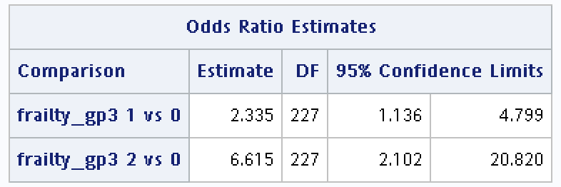Frailty vs. robust：6.61( 95% CI : 2.10 – 20.82)

* + - * 1. Male：

Prefrailty vs. robust：1.34 ( 95% CI : 0.58 – 3.10)

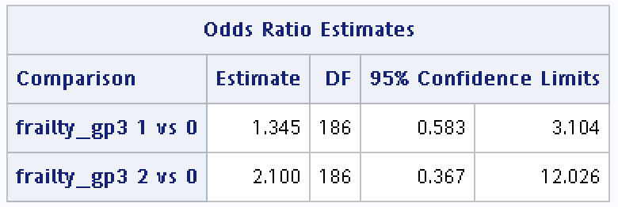Frailty vs. robust：2.10 ( 95% CI : 0.37 – 12.02)

* + - 1. Description：
         1. Female與male兩組差異甚大，可能sex與frailty status之間具有interaction。
    1. Age group：
       1. Stratum specific odds ratio：
          1. Under and equal to 74：

Prefrailty vs. robust：1.50 ( 95% CI：0.68 – 3.31)

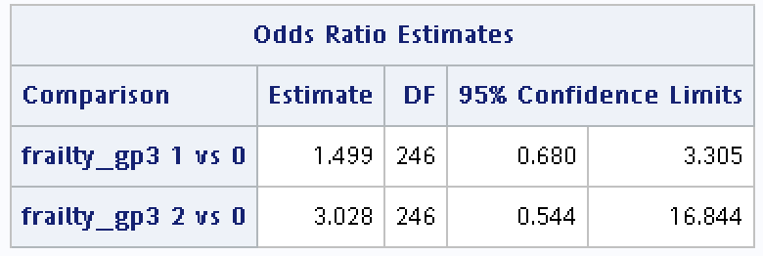Frailty vs. robust：3.03 ( 95% CI : 0.54 – 16.84)

* + - * 1. Over and equal to 75：

Prefrailty vs. robust：1.64 ( 95% CI: 0.74 – 3.62)

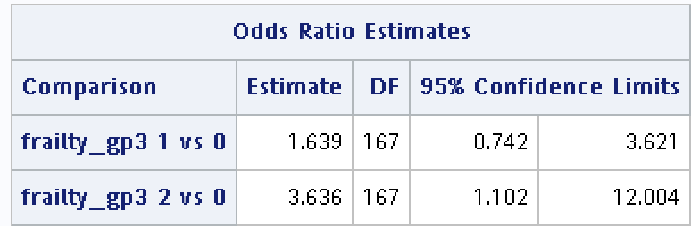Frailty vs. robust：3.63 (95% CI : 1.10 – 12.00)

* + - 1. Descriptions：
         1. 兩組差異並不大，比較age與frailty status比較不可能有interaction。
    1. APOE e4 status：
       1. Stratum specific odds ratio：
          1. Non-carrier：

Prefrailty vs. robust：1.89 ( 95% CI：1.04 – 3.43)

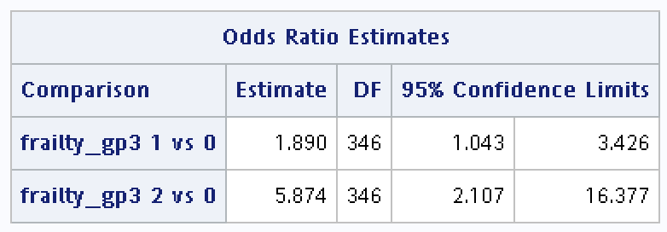Frailty vs. robust：5.87 ( 95% CI : 2.11 – 16.38)

* + - * 1. Carrier：

Prefrailty vs. robust：1.56 ( 95% CI: 0.40 – 6.13)

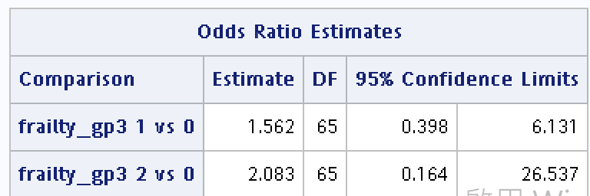Frailty vs. robust：2.08 (95% CI : 0.16 – 26.53)

* + - 1. Descriptions：
         1. 兩組差異甚大，尤其是frailty vs. robust的odds ratio。APOE e4 status與frailty status可能具有interactions。
    1. Code (q3) :

dm "odsresult" clear;

dm "log" clear;

*/*q3 : use GLMM to perform stratified analysis by sex, age, group, and APOE status at baseline */*

*/* sex */*

title "q3 stratified by sex";

**proc** **sort** data = baseline2;

by sex;

**run**;

**proc** **glimmix** data = baseline2 order = data;

by sex;

class new_id frailty_gp3(ref = "0");

model mocabi(event = "1") = frailty_gp3 / dist = binary link = logit solution or(label);

**run**;

*/* age */*

title "q3 stratified by age";

**data** baseline3;

set baseline2;

if age = . then agebi = .;

else if age <= 74 then agebi = 0;

else agebi = 1;

**run**;

**proc** **sort** data = baseline3;

by agebi;

**run**;

**proc** **glimmix** data = baseline3 order = data;

by agebi;

class new_id frailty_gp3(ref = "0");

model mocabi(event = "1") = frailty_gp3 / dist = binary link = logit solution or(label);

**run**;

*/* APOE status */*

title "q3 stratified by APOE status";

**proc** **sort** data = baseline3;

by apo4car;

**run**;

**proc** **glimmix** data = baseline3 order = data;

by apo4car;

class new_id frailty_gp3(ref = "0");

model mocabi(event = "1") = frailty_gp3 / dist = binary link = logit solution or(label);

**run**;

* 1. Propensity score：
     1. Result：
        1. 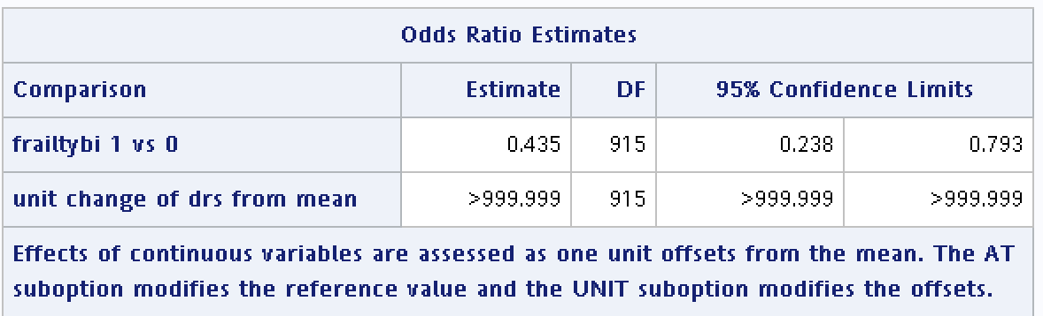首先，用GLMM model 計算結果模型不會收斂。（如下圖）
        2. 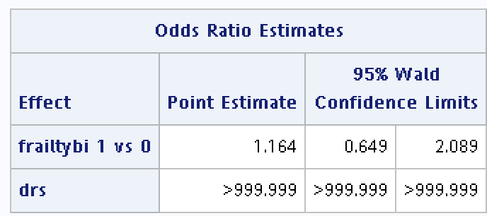改用logistic model並只取baseline的資料，模型依然收斂不了。
     2. Descriptions：
        1. 我嘗試只放一個age或只放一個gait進入模型，也都無法收斂。此外，我尚嘗試將age及gait變為類別變項放入模型也無法收斂，不論是用long data的GLMM model或是只用baseline data的logistic model。
        2. 我不太清楚為什麼模型會收斂不了QQ
     3. 與Q2的比較：
        1. 若先不論DRS收斂不了的問題，本題若以GLMM model計算的結果，frailty變為cognition impairment顯著的保護因子（Q2的結果frailty與outcome的關係不顯著）
        2. 我想這樣的結果不太合理，也沒有先前文獻支持這樣的結果。我想這個結果與模型無法收斂有關，而模型無法收斂可能跟資料分布或是propensity score的計算方式有關。
     4. Code (q4)

dm "log" clear;

dm "odsresult" clear;

*/*q4 : use GLMM to estimate propensity score */*

**proc** **glimmix** data = frailty;

class new_id ;

model mocabi(event = "1") = age gait / dist = binary link = logit solution or (label);

random intercept / subject = new_id;

output out = drs predicted = pred_value;

**run**;

**data** drs2;

set drs;

drs = exp(pred_value) / (1 + exp(pred_value));

**run**;

**proc** **glimmix** data = drs2;

class new_id frailtybi (ref = "0");

model mocabi(event = "1") = frailtybi drs / dist = binary link = logit solution or(label);

random intercept / subject = new_id;

**run**;

**data** baseline2;

set baseline;

if mocasco = . then mocabi = .;

else if mocasco >= 24 then mocabi = 0;

else mocabi = 1;

if frailty_gp3 = . then frailtybi = .;

else if frailty_gp3 = 0 then frailtybi = 0;

else frailtybi = 1;

if htn = . then htnbi = .;

else if htn = 0 then htnbi = 0;

else htnbi = 1;

if dm = . then dmbi = .;

else if dm = 0 then dmbi = 0;

else dmbi = 1;

if chol = . then cholbi = .;

else if chol = 0 then cholbi = 0;

else cholbi = 1;

**run**;

**proc** **logistic** data = baseline2;

class new_id ;

model mocabi(event = "1") = age gait ;

output out = drs predicted = pred_value;

**run**;

**data** drs2;

set drs;

drs = exp(pred_value) / (1 + exp(pred_value));

**run**;

**proc** **logistic** data = drs2;

class frailtybi (ref = "0");

model mocabi(event = "1") = frailtybi drs ;

**run**;